Review on SQL Join Operator

G T V Eswar (21MSM3002)

gtveswar637@gmail.com

Chandigarh University

Abstract

This paper is created for give a brief description about SQL JOIN operator. You will get an idea about join where do we use and how to handle it. Sql is used to combine records(rows) from two or more tables in a database. A JOIN is a means for combining fields from two tables by using values common to each. There are different types of JOIN operators in SQL based on different purposes. The most common type of join are INNER | OUTER | CROSS.

Content

1. Introduction
2. Preliminaries
3. Inner join
   1. Equi join
   2. Non equi join
4. Outer join
   1. Left outer join
   2. Right outer join
   3. Full outer join
5. Cross or Cartesian join
6. references

INTRODUCTION:

The author Abraham Silberschatz explained join operator in a book (Database System Concepts sixth edition) as “SQL join operator is used to combine records from two or more tables based on a common fields between them”. In sql there are different types of join operators are placed which are differenced according to their definitions. Inner join is for returning the common records between the two tables and it had two types of join they are equi join which returns the common records of the table and non equi join it will return the database according to the comparison operators.

Next we have outer join which is the most used joins in the sql it has three types of the join in it namely left outer join, right outer join, full outer join. The best advantage of the outer join is you can easily guess the definition of the operator like left outer join returns that it will return the whole left table in the result and the right outer join return the right table of the database in the result and finally full outer join which return the total two table in the result. These are the sql join which are very helpful in the business sections, like when you need to select the related data of the left table or the right table or if you want to select the table according to the Cartesian product of the both tables then there is an option join operator which is called as cross or Cartesian join.

Finally the cross join which is also called as Cartesian join. It is called as Cartesian join because it products the elements in the tables of the table in Cartesian product which is completely similar to the mathematical method in real life. In mathematical model every element in one vector will be produced to the every element in another table.

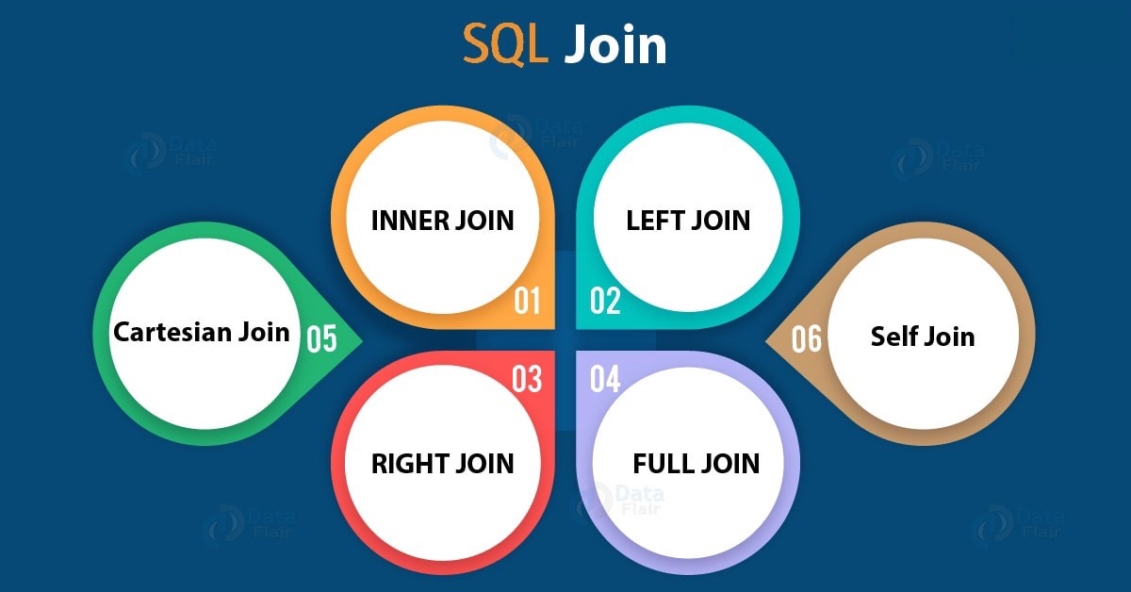

Preliminaries

As we have discussed earlier in SQL join operator there are different types for different situations as, Inner join, Outer join, Semi join, Left join, Right join and so on. Let’s know each topic in detail. Types of joins present in sql database.

1. Inner join
   1. Inner join | equi join
   2. Non-equi join
2. Outer join
   1. Left outer join | left join
   2. Right outer join | right join
3. Cross join | Cartesian join

**Inner Join:**  In joins Inner join is used more often than other joins There are two types of inner joins in SQL database.

1. Inner or equi join
2. Non-equi join

**Inner or equi join:** .This is called as Equijoin because it returns all the common records from the table we have mentioned. When we mention inner join in our query it will return all the records of a table which are repeated in the second table also, that is all the common rows. For instance we have two tables namely salesorder and salesorder_details the query can be written as

**Syntax:** select * from table1 inner join table2 on table1.record = table2.record;

**Example:** select * from salesorder inner join salesorder_details on salesorder.orderno=salesorder_details.orderno;

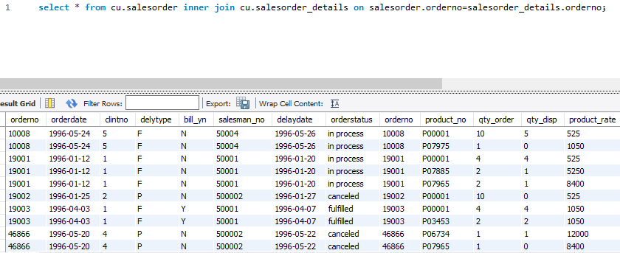

I’m using Mysql workbench so there will be a short difference between the codes. The output will be like this. These are the total no.of records which are in common in these two tables. This inner join is also can be written in the form of where Claus like bellow

**Syntax:** SELECT table1.col1,table2.col2, table1.col2…. form table1,table2 WHERE table1.col=table2.col;

**Example:** SELECT s.clintno,s.orderdate,ss.product_no,ss.qty_order FROM salesorder s, salesorder_details ss WHERE s.orderno=ss.orderno;

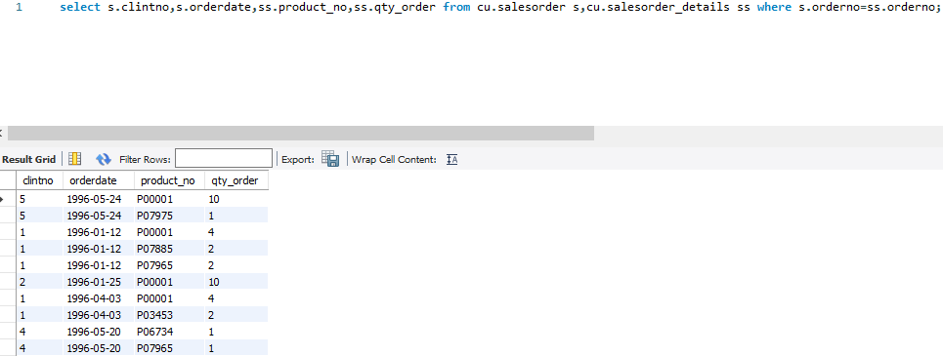

**Non-equi join:** In equi join we use = operator to output records but in non-equi join we use comparison operators except =. The code is written with the help of where claus like where col1 >=col2.

**Syntax:** SELECT table1.col1,table2.col2….

FROM table1, table2

WHERE table1.col >=|<=|<|> table2.col;

**Example:** select s.clintno,s.orderdate,ss.product_no,ss.qty_order from cu.salesorder s,cu.salesorder_details ss where s.orderno<ss.orderno;

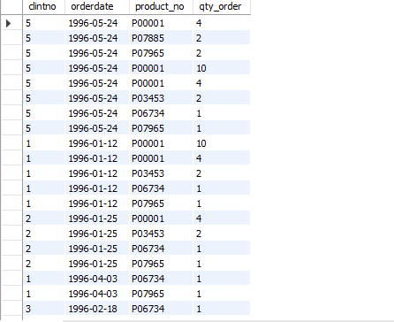

**Outer join:** we finally know the purpouse and usage of inner join it results the output as per common or comparison operators. Unlike inner join outer join returns the uncommon or not equal records from the two tables. There are three types of outer join available in SQL database which are

1. Left outer join | left join
2. Right outer join | right join
3. Full outer join | full join

**Left Join | left outer join:** The keyword left join indicates that it will take left table (table1) as primary table and then compares it with right table (table2), it will print the whole left table even there is no common records between those tables. If there is common records then It prints the total left table in addition with common records of right table, if there is no common records then we will get all the records from the table1 and all the records from table2 which will be displayed as NULL values.

**Syntax:** select * from table1 left join table2 on table1.record = table2.record;

**Eample:** select * from salesorder left join client_master on salesorder.orderno=client_master.clint_no;

In this example we have taken two tables in which there is no common records then as per our definition we get output like bellow.

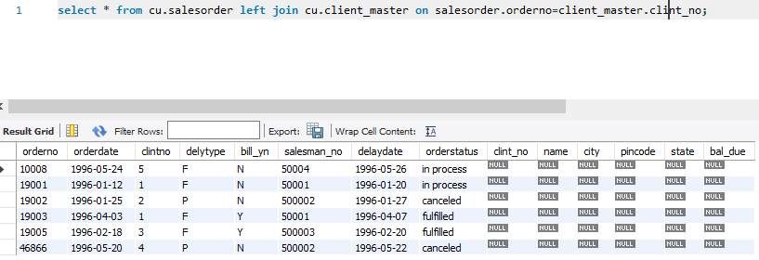

**Right join | right outer join:** For right join we can simply say opposite to left join. It will take right table (table2) as primary table and then compares it with left table (table1), it will print the whole right table even there is no common records between those tables. If there is common records then It prints the total right table in addition with common records of left table, if there is no common records then we will get all the records from the table2 and all the records from table1 which will be displayed as NULL values. In our next example we have taken two tables in which there is no common records then as per our definition we get output like bellow.Now you can clearly get the difference between left and right join.

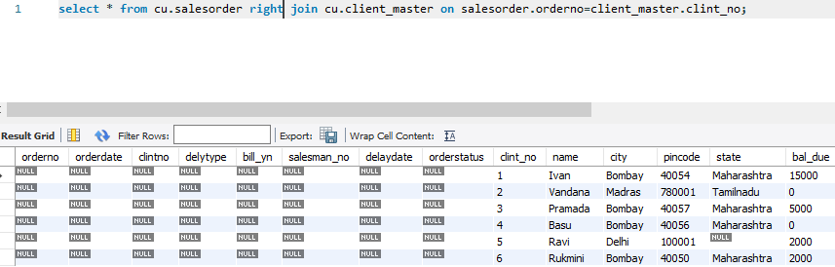

**Full join | full outer join:** As the name mentions full join means it prints the total records from table1 and table2 also. That means we get every record presented in the both tables even there is no common or similar records. In our example we take same tables in which there is no common records then full join returns like bellow.

**Syntax:** select * from table1 full join table2 on table1.record = table2.record;

**Example:**  select orderno,orderdate,clintno from cu.salesorder full join cu.salesorder_details on salesorder.orderno=salesorder_details.orderno;

Now we have completed outer join section let know about another join operator in sql database which is called as cross join or Cartesian join.

**Cross join | Cartesian join:** The term cross join refers that it results the Cartesian product of the both table1 and table2. That is we can write command without mentioning the word cross join, we can use from claus to get same output.

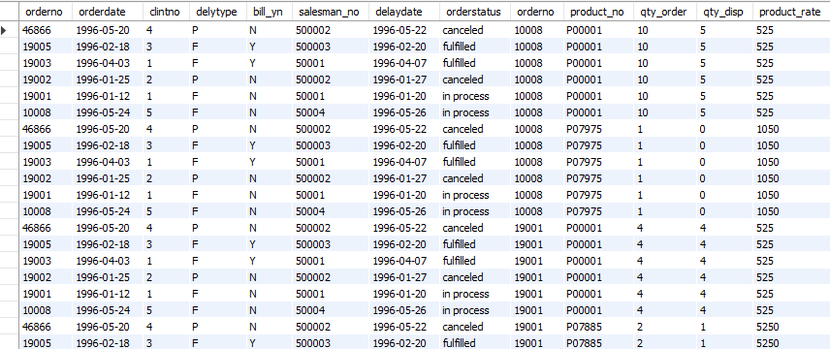

References

1. Data base system concepts sixth edition by Abraham Silberschatz | Henry F.Korth | S. Sudarshan
2. Kvr software technologies